**Surabee Integrated Rehabilitation Centre for Addicts**

**Shivamogga**

* **Sanitizing to the all rooms and office surrounding**

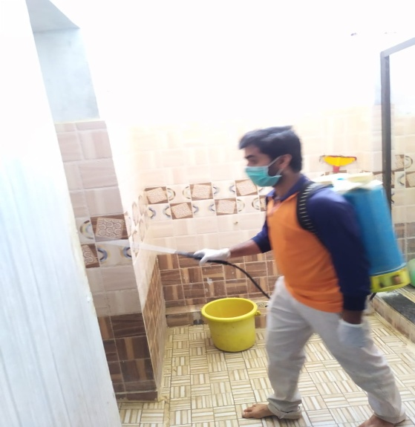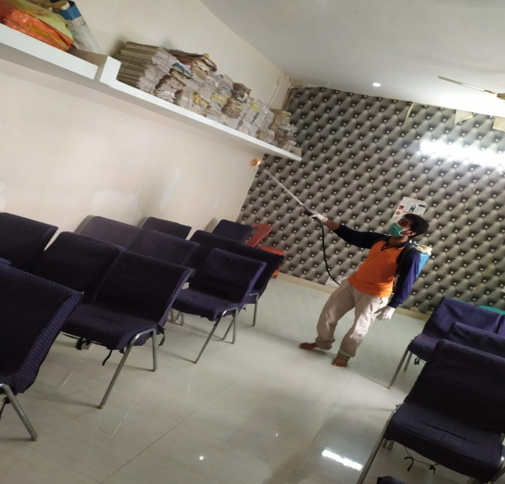

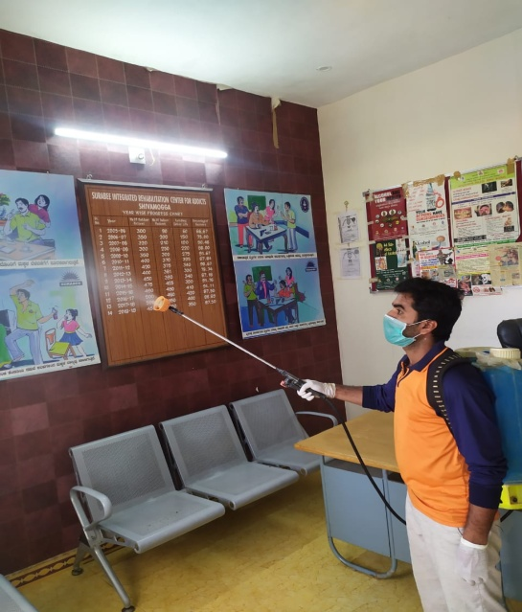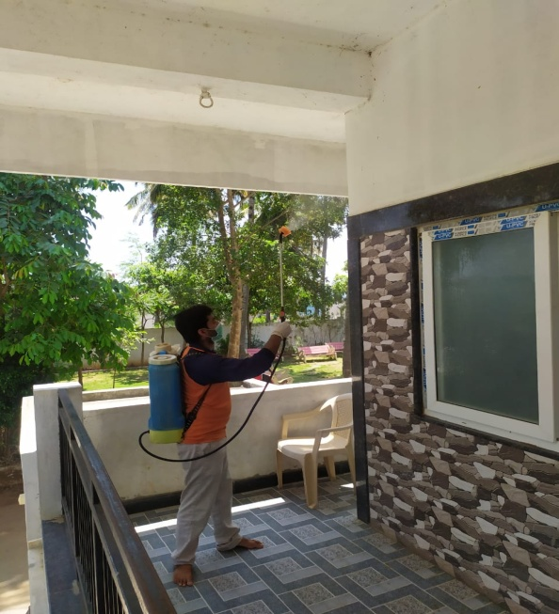

* **Ambedkar Jayanthi Celebration**

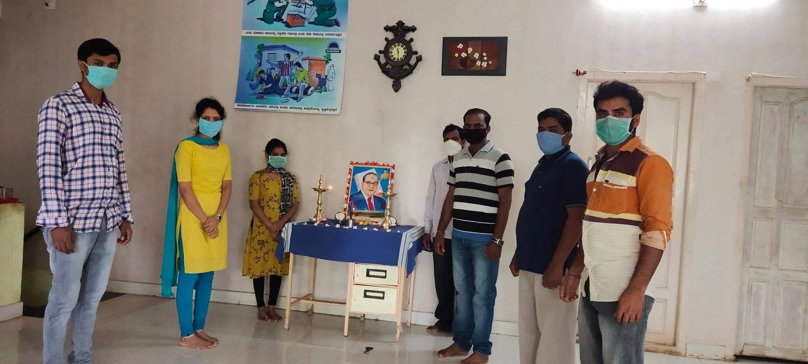

* **Mr. Eranna Panchal Deputy Director of Women & Child Development Deportment Shimoga, & Smt. Gangubai Protection officer, Woman and child development department ,Shimoga, visited to our Center On 30th April 2020,**

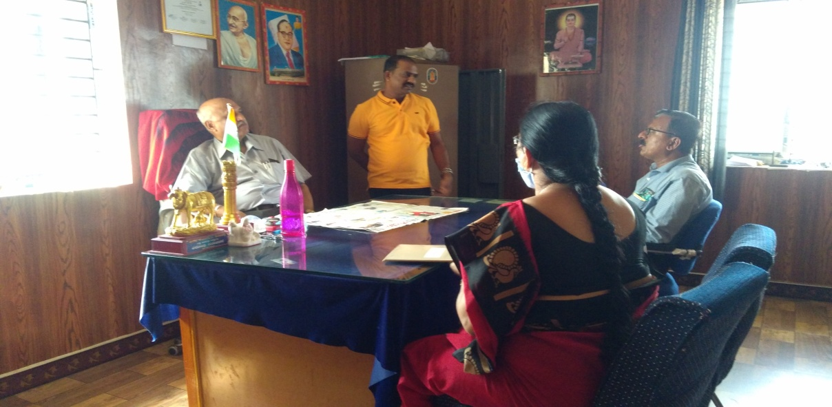

* **CELEBRATION OF INTERNATIONAL DAY AGAINST DRUG ABUSE AND ILLICT TRAFFICKING ON 26th JUNE- 2020:**

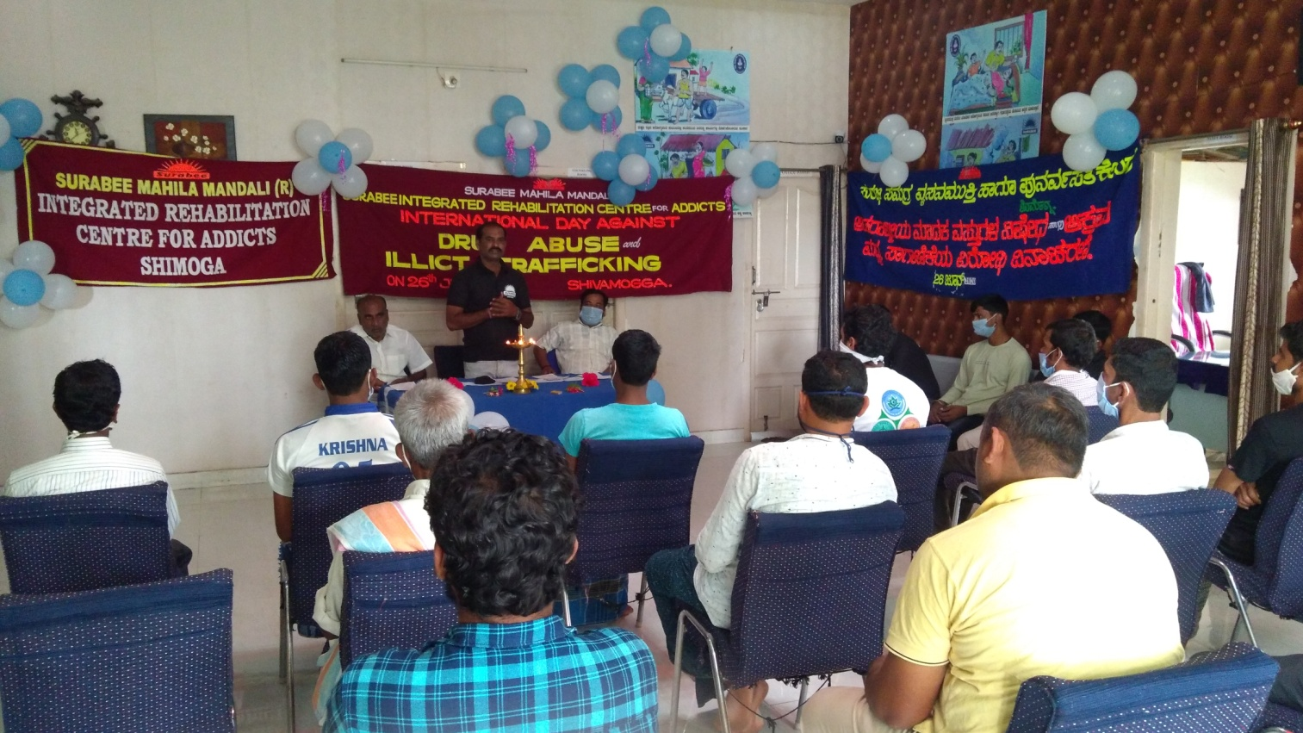

* **On 29th June 2020 Organized send of programme to honor Mr. Eranna Panchal, Deputy Drirector, Women and Child development Dept, Shimoga, bye Surabhi Mahila Mandali ® Surabee Integreated Rehabilitation Center for addicts, Shimoga.**
* 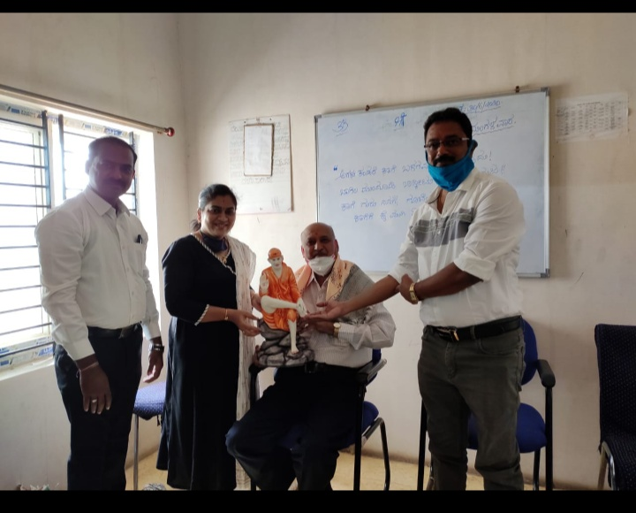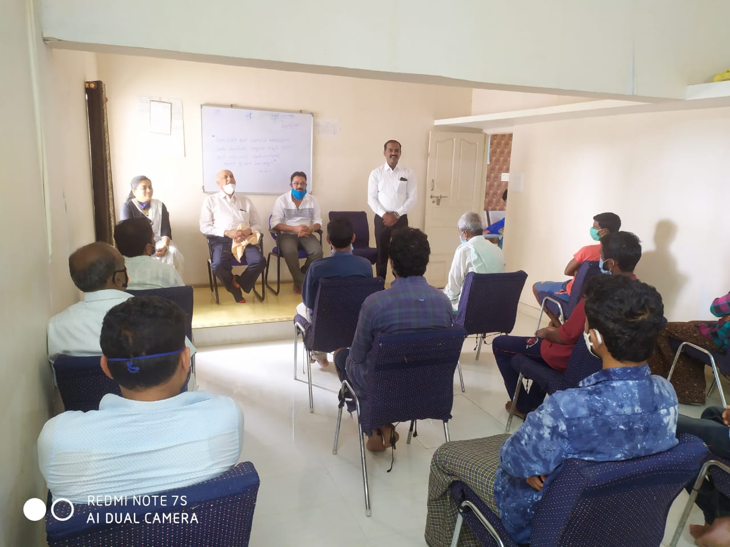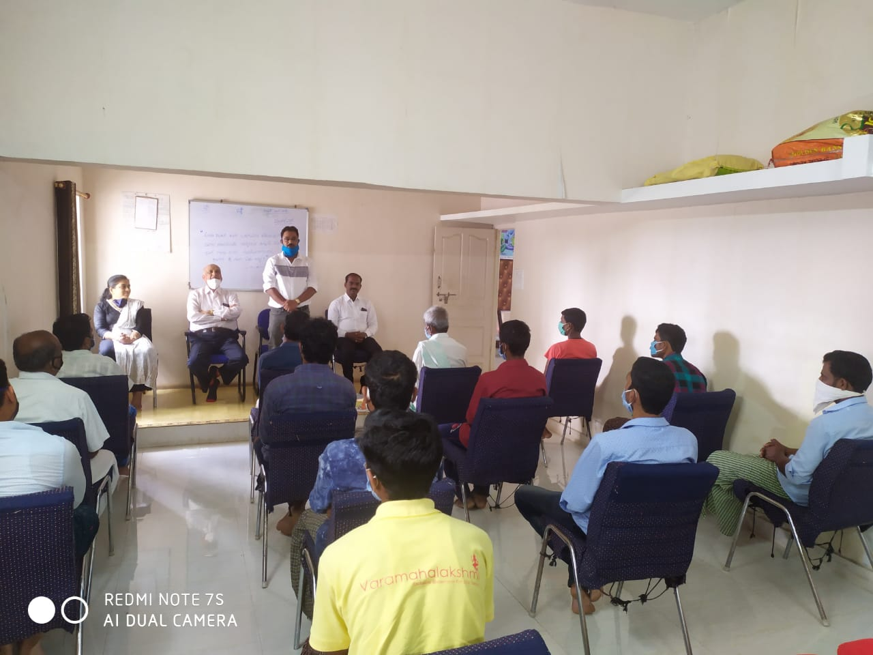
* **District mental health team visited to our Center On 30th June 2020,** 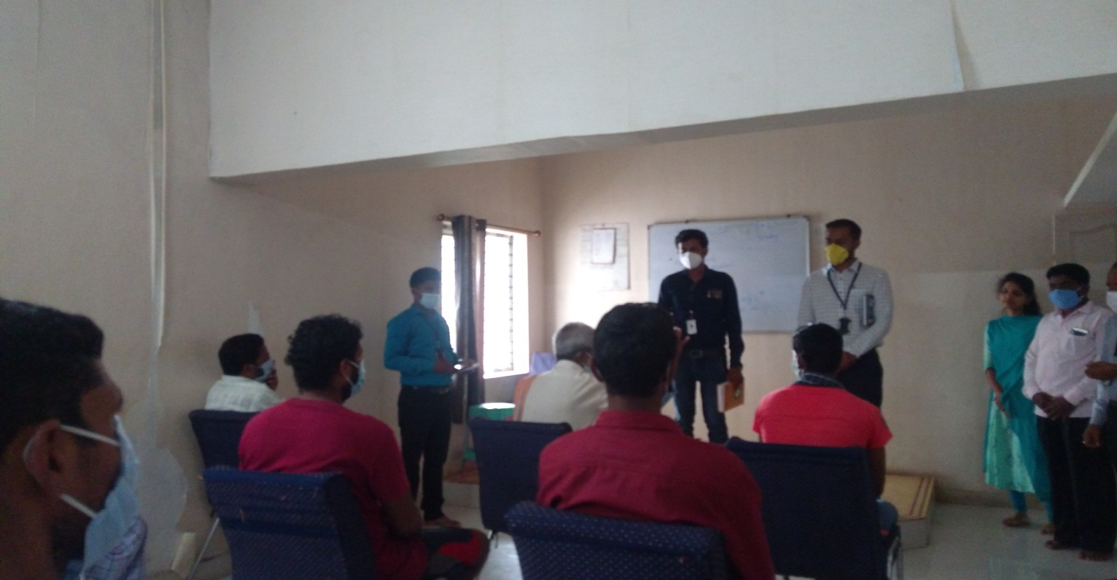
* **Smt Shilpa M. Doddamani District Disabled Welfare officer visited to our center On 30th July 2020**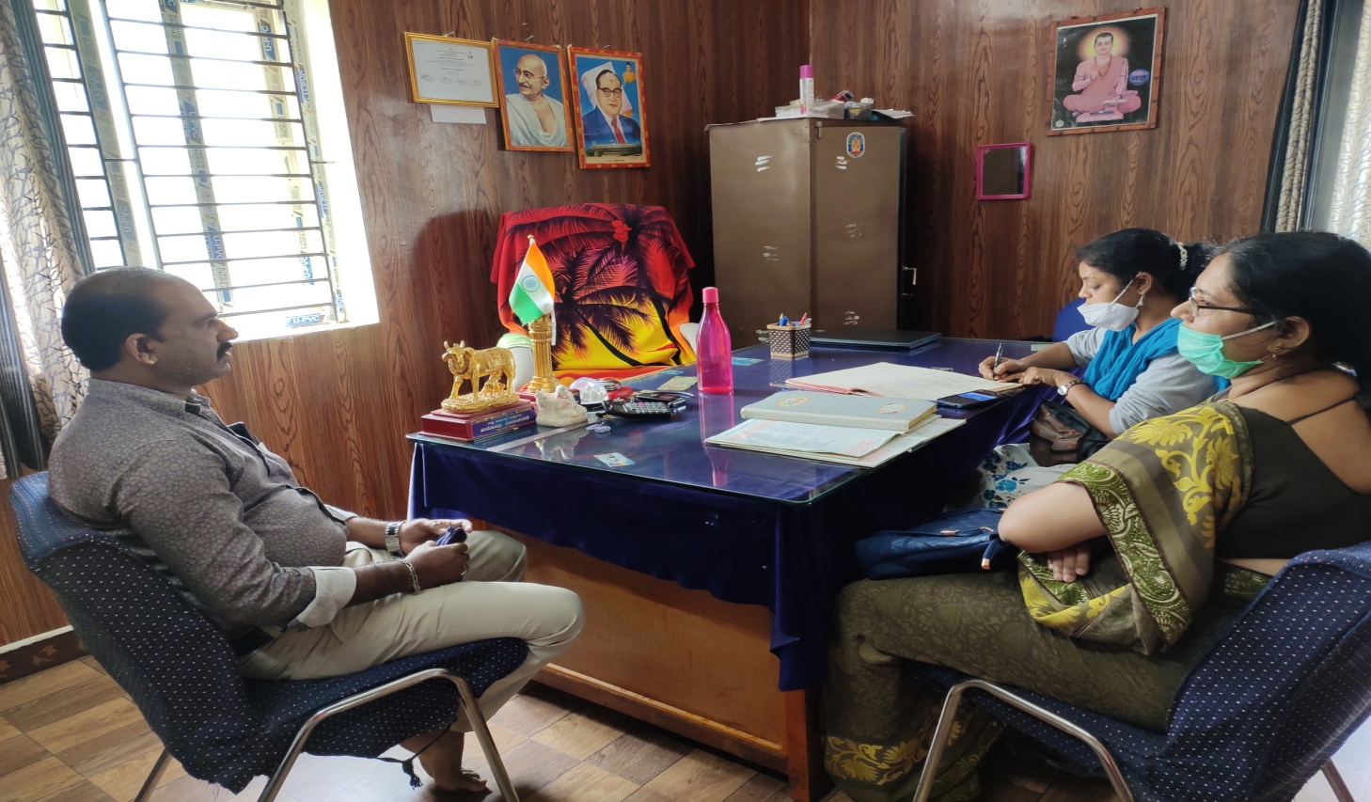
* **Independence Day**

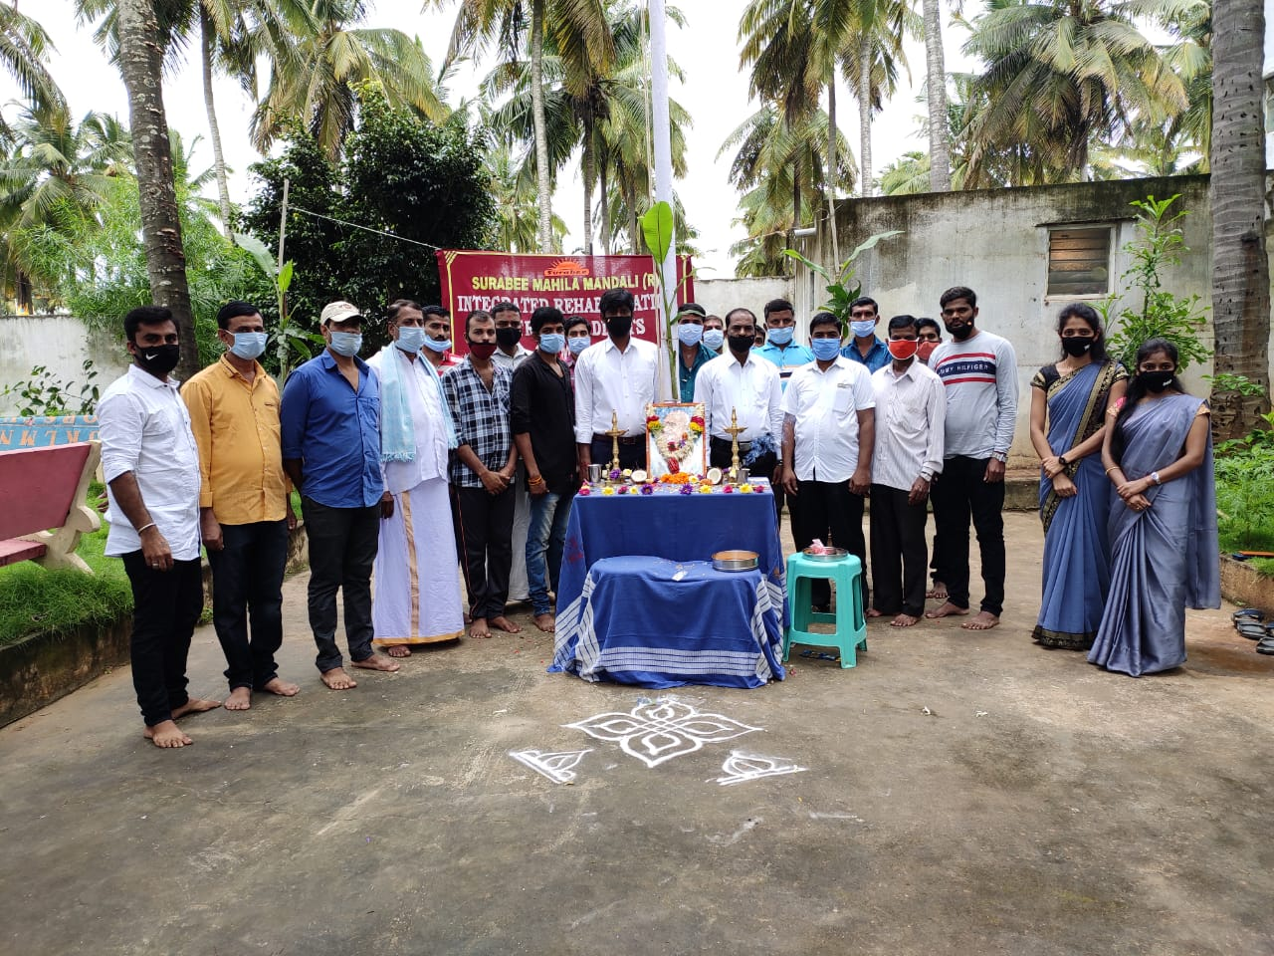

* **Ganesha Festival Celibration**

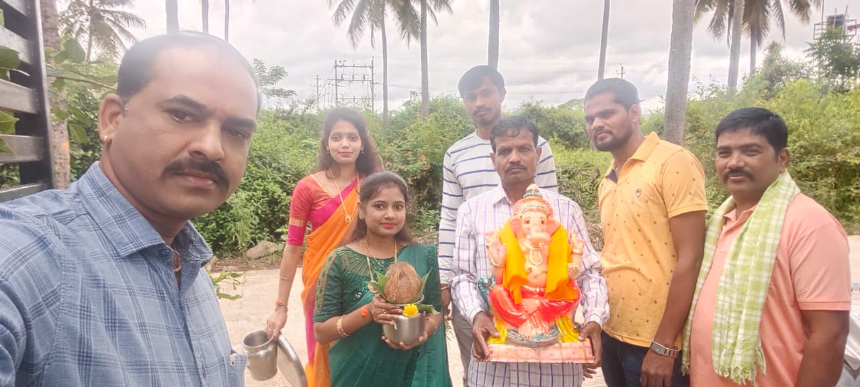

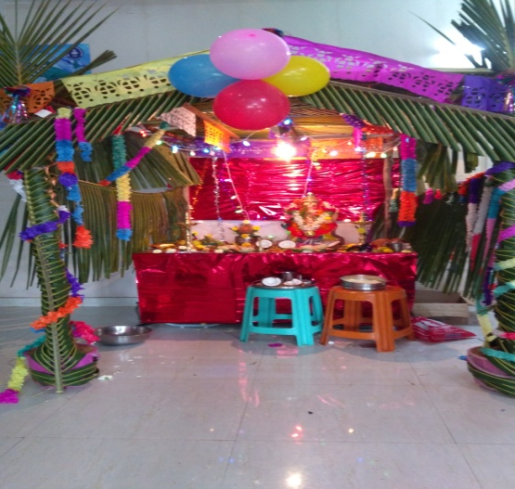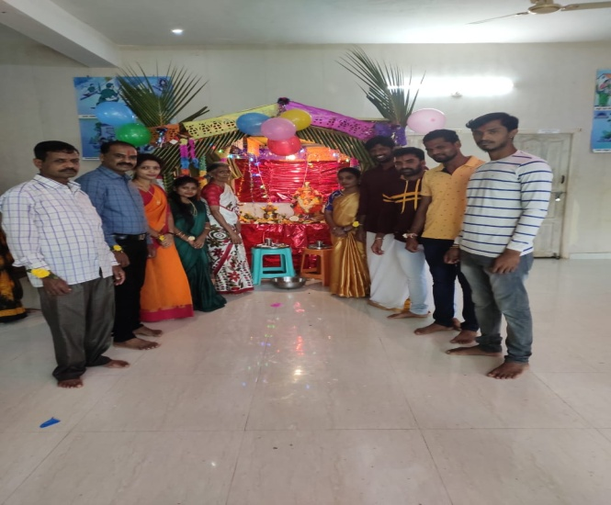

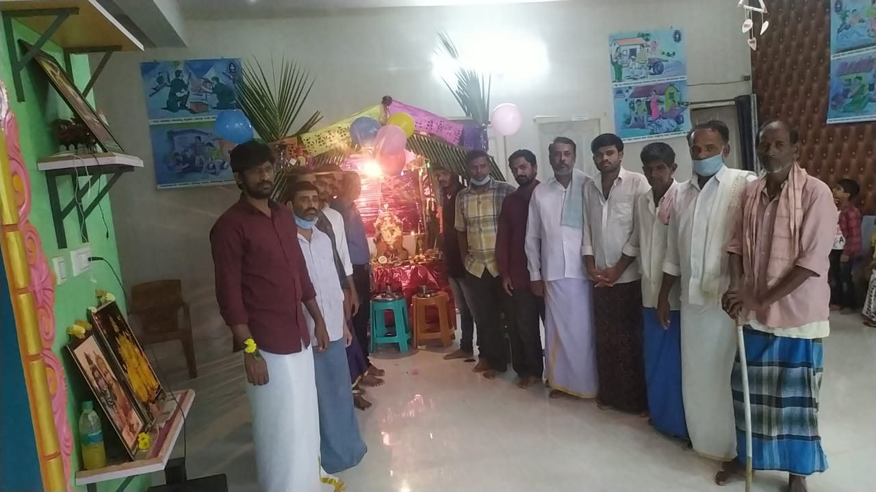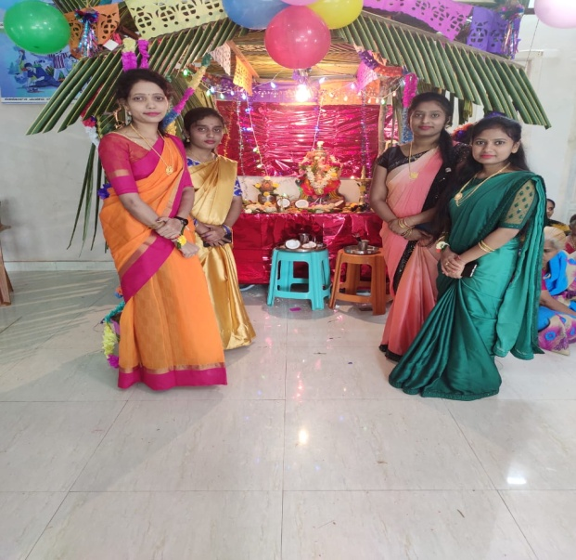

* **Mr. Aneesh V Suresh MSJE, PMV state co-ordinator visited to our Center On 24th September 2020**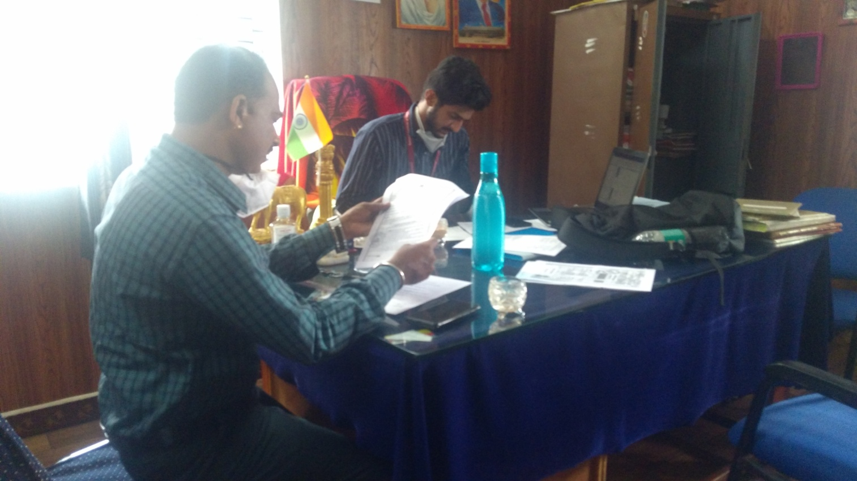
* **Gandhi Jayanthi Celebration**

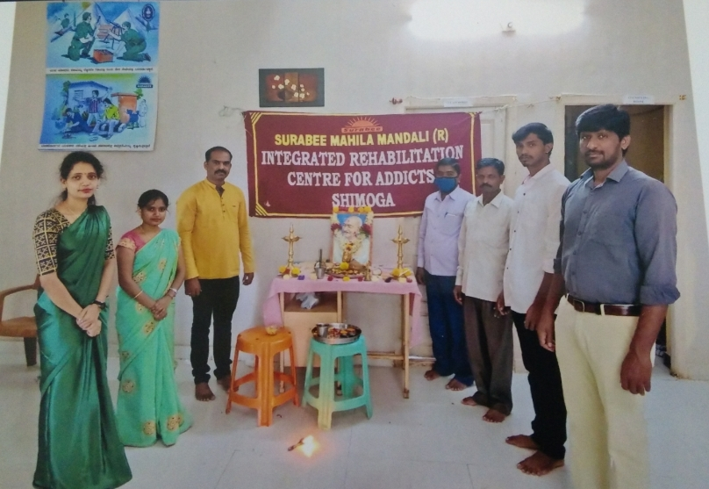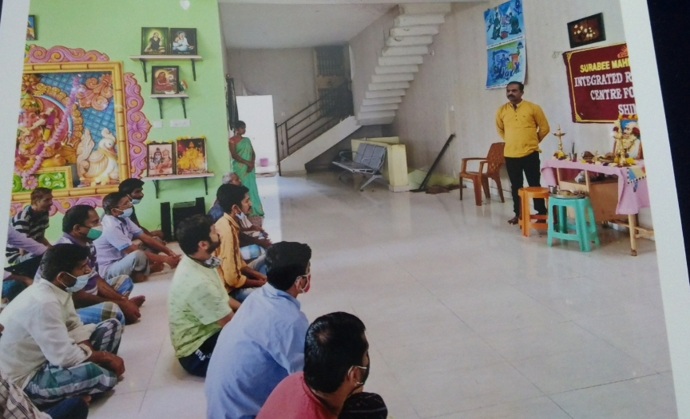

* **Kannada Rajyotsava Celebration with clients**

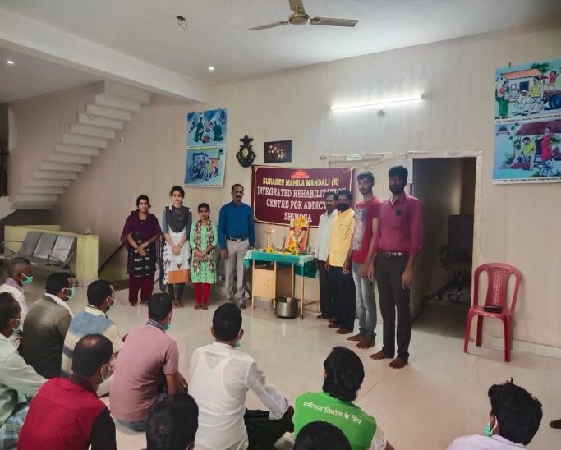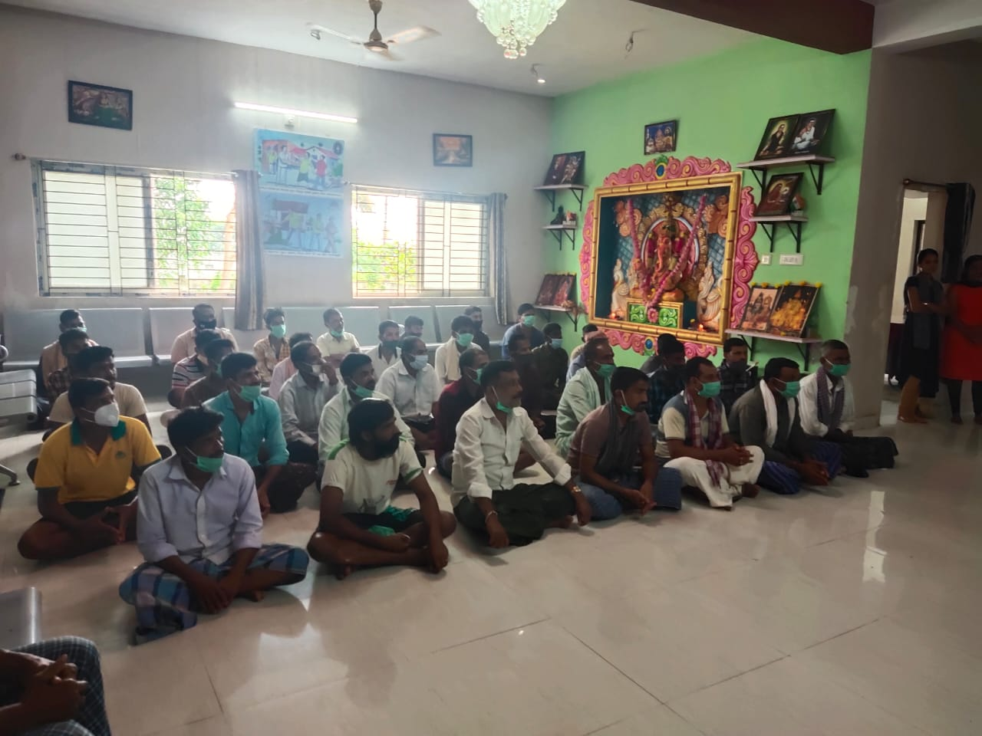

* **Divali festival Celebration with clients**

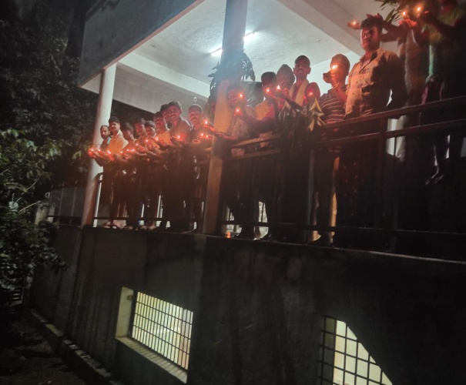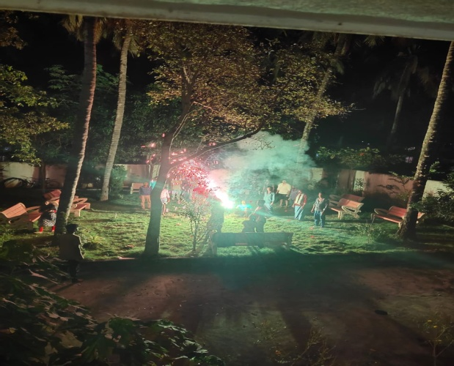

* **New year celebration with clients**

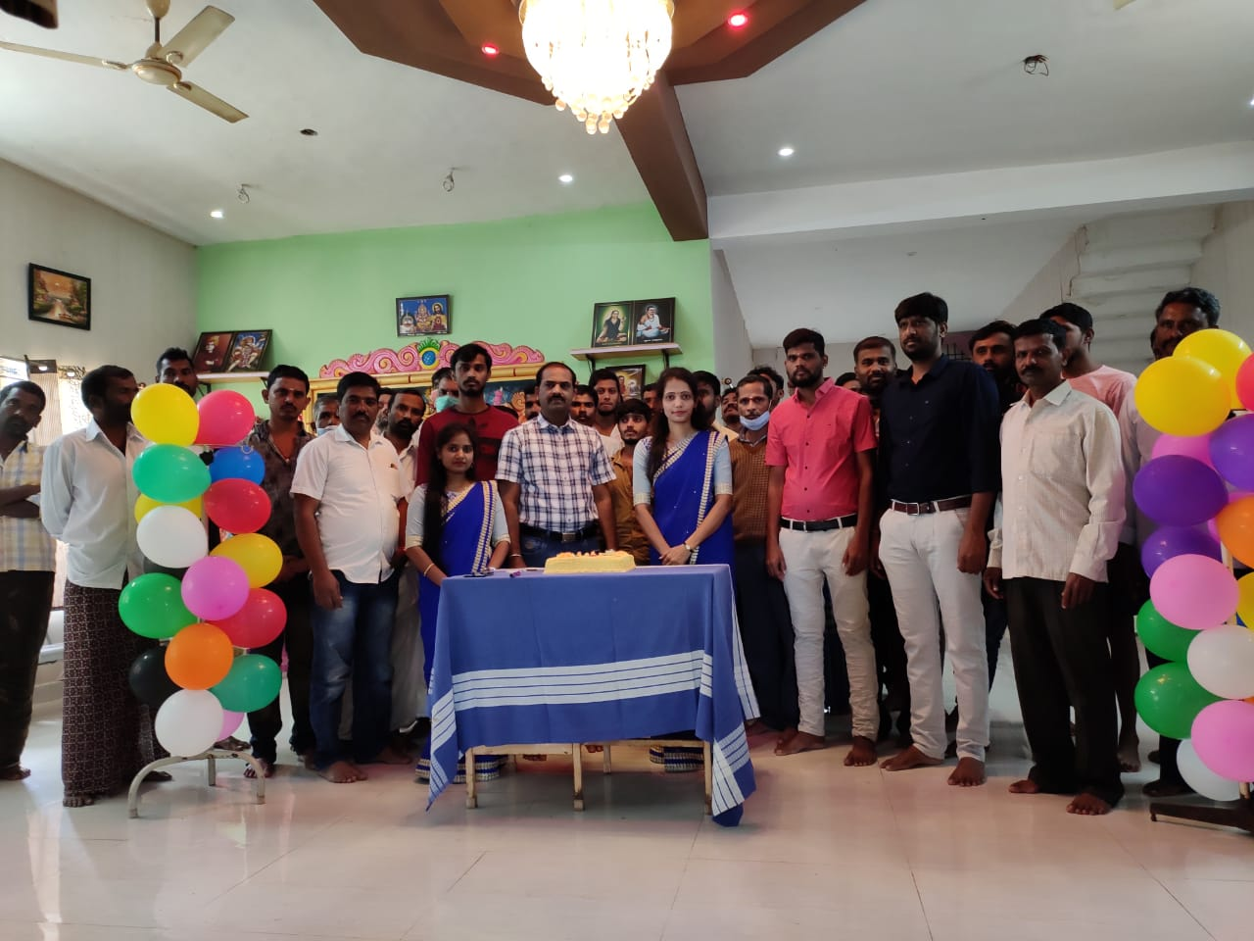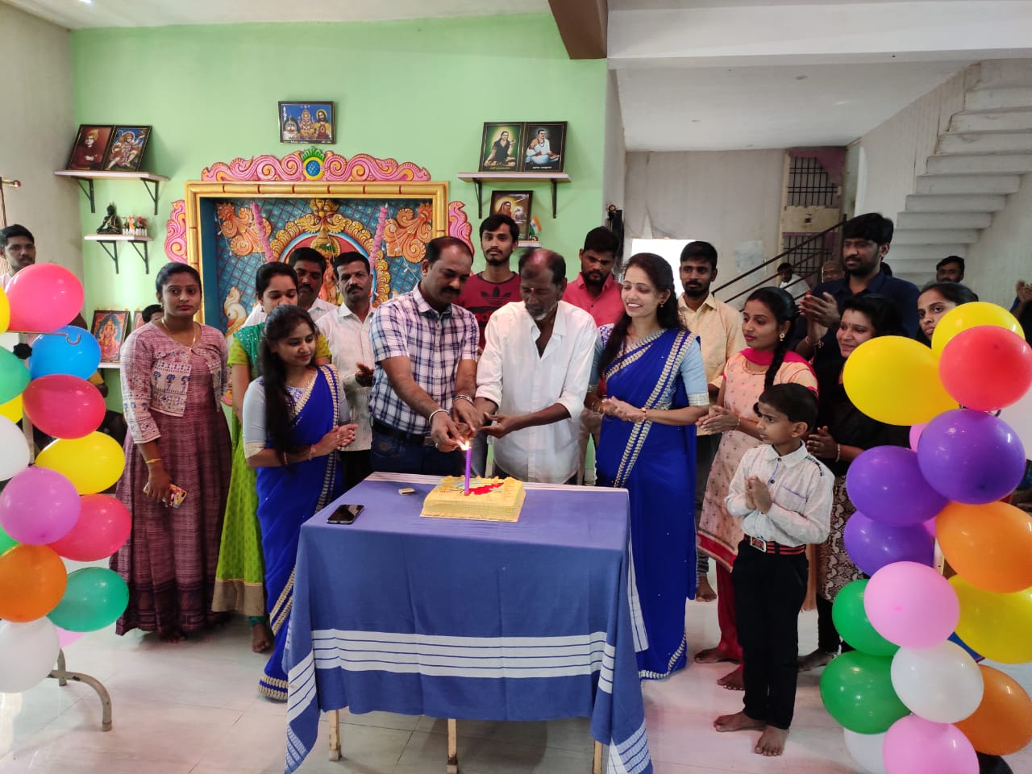

* **A A Meeting**

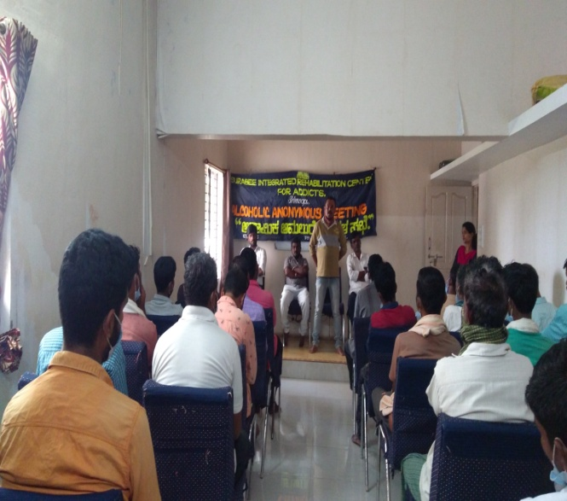

* **Republic Day celebration with the clients**

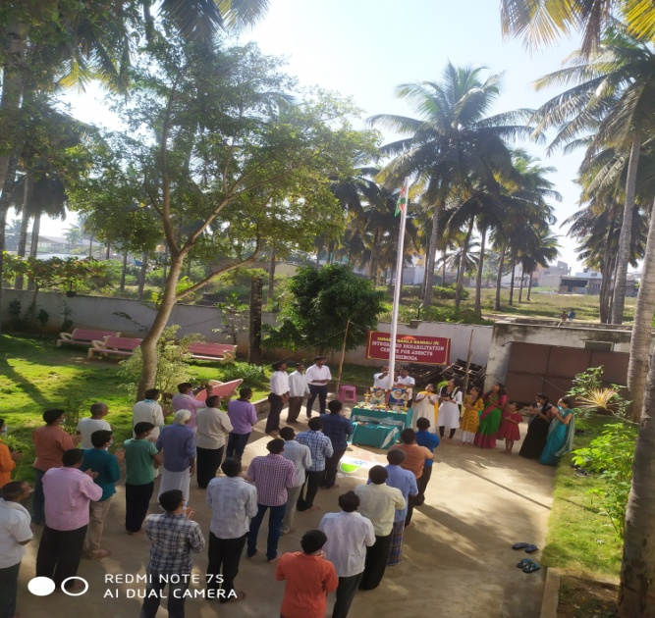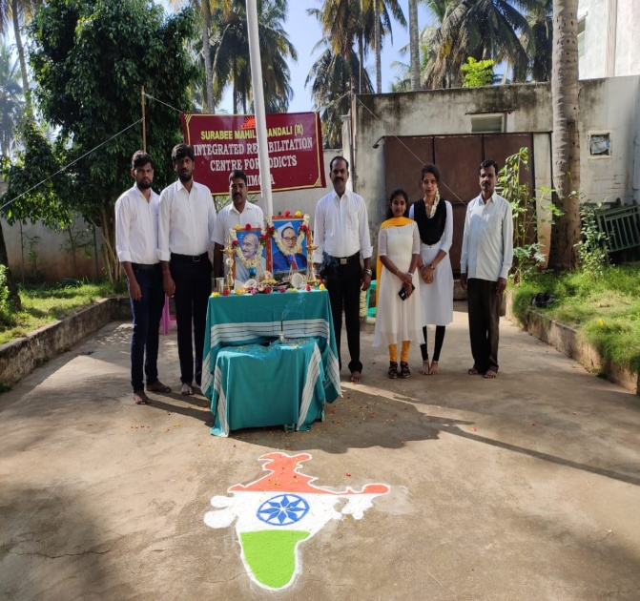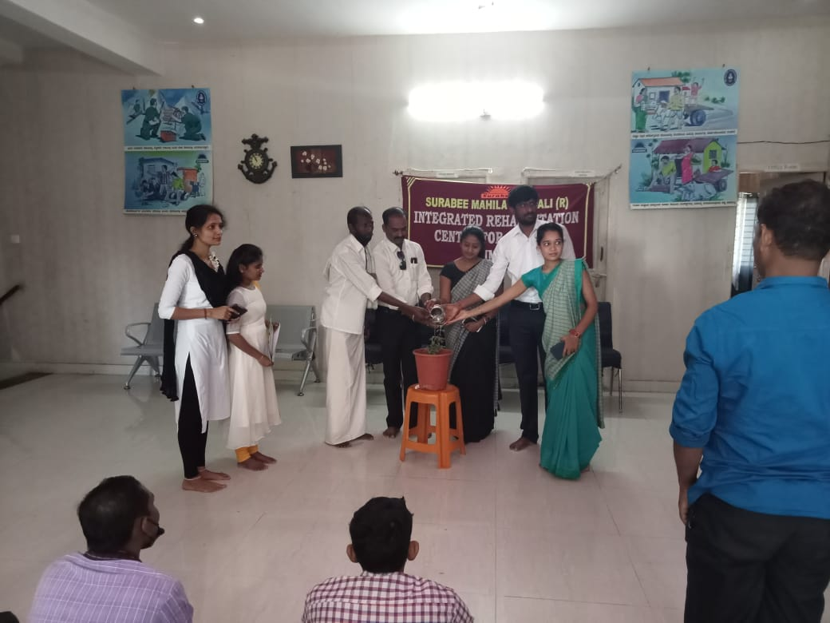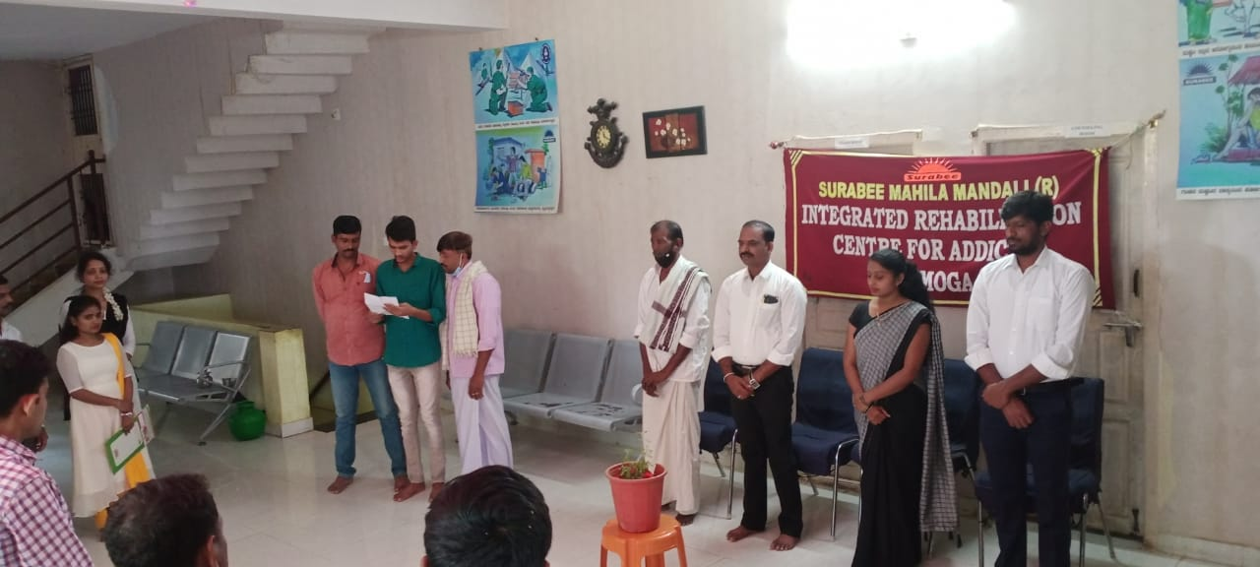

* **Clients were participated in Cultural programs in the event of Republic Day programme.**

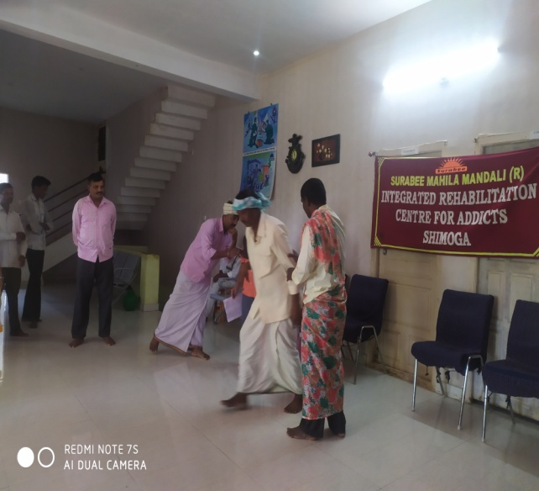

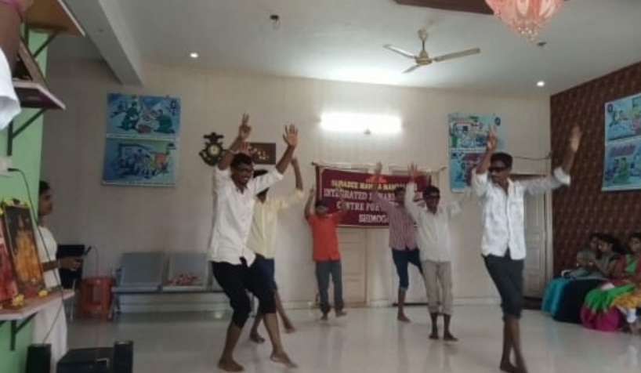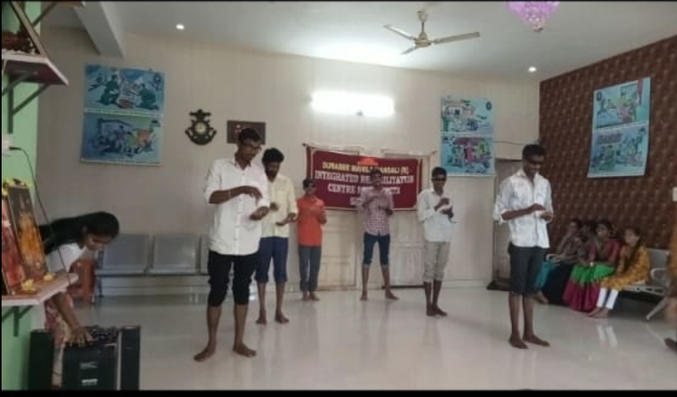

* **On 3rd February 2020 Kuvempu University, Dept of Social Work, students were visited to our centre regarding academic orientation programme.**

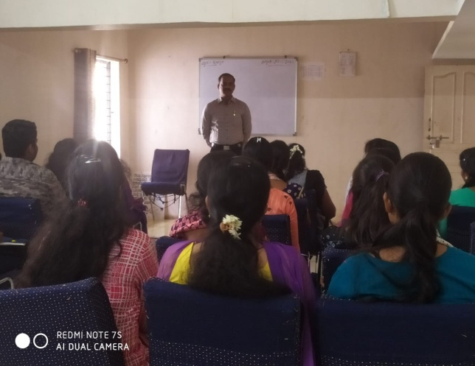 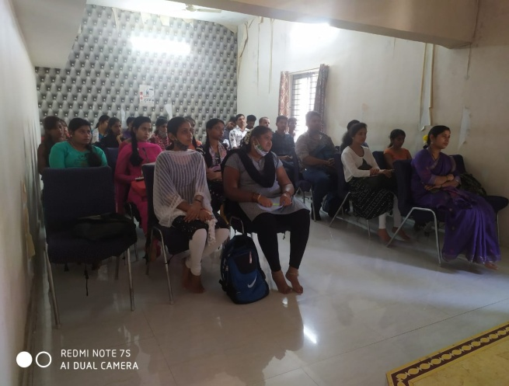

**Mr. Shivanna K.B. Project Director of Surabee IRCA Shimoga, he is giving information about our organization to the students.**